Task A





Task B

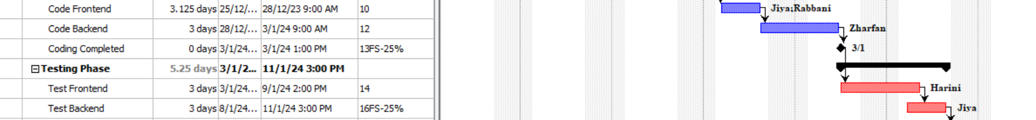

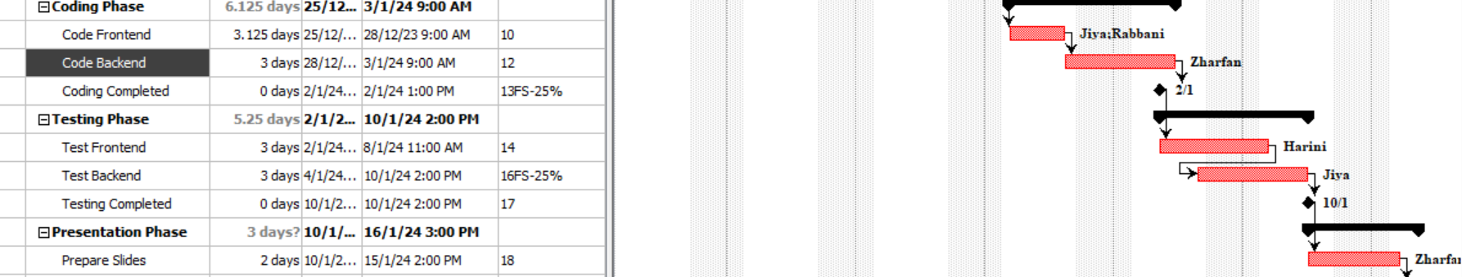

Task C

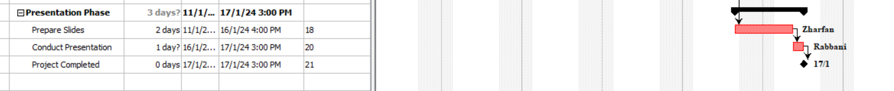

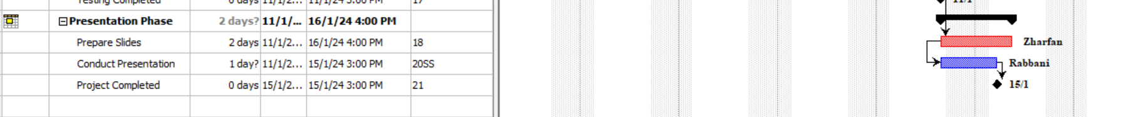

Task D

Task E

Task F

